**“Silent Lessons”**

**Retrospective**

Module 1

Instructor: Christian Avigni

Maximilian Schneider

E-Mail: maximilian.schneider392@escapestudios.ac.uk

Student ID: 25101392

Course : MA Game Art

**Contents**

1 Introduction 1

2 Chapter 1 - Art Direction *(Week 1)* 1

2.1 Art Bible & Direction 1

2.1.1 Concept Development 1

2.1.2 Mood Board & Visual Exploration 2

2.1.3 Colour Palette 3

2.2 Level Planning & Layout 3

2.2.1 Conceptual Arrangement 3

2.2.2 Form & Proportions 4

3 Chapter 2 - Modelling *(Weeks 2-3)* 6

3.1 Asset Overview 6

3.2 Workflow & Steps 6

3.3 Optimisation & Performance 7

4 Chapter 3 – Trim Sheets & Atlas *(Weeks 3-5)* 7

4.1 Planning & Design Approach 7

4.2 Texture Creation 8

4.3 Implementation 8

4.3.1 Trim Sheets 8

4.3.2 Image Atlas 9

4.3.3 Floor Texture 10

4.4 Material implementation 10

5 Chapter 4 – Lighting *(Weeks 5-6)* 12

5.1 Challenges 12

5.2 Approach 13

6 Conclusion (retrospective) 15

7 Bibliography 16

8 List of Figures References 16

**List of Figures**

Figure 1: Mood Board 2

Figure 2: Cosy Colour Palette 3

Figure 3: Photoshop Level Layout 3

Figure 4: Unreal Engine Blockout Test 4

Figure 5: Basic Blender Blockout 5

Figure 6: Blender Final Base Meshes 7

Figure 7: Trim Sheet Wall Texture 8

Figure 8: Trim Sheet Material Texture 9

Figure 9: Atlas Image Texture 9

Figure 10: Atlas Floor Texture 10

Figure 11: Master Material Unreal Graph 10

Figure 12: Unreal Assets with Material 11

Figure 13: Level Light Density 12

Figure 14: Light Colour Palette 13

Figure 15: Light Bake Top-Down View 13

Figure 16: Light Bake Top-Down & Close-Up View 14

**Summary**

This document reflects the workflow and creative decisions behind the Module 1 project, Silent Lessons. Its purpose is twofold: to document the technical and artistic processes I applied, and to serve as a reference for future personal projects.

The focus is on the areas that posed the greatest challenges and learning opportunities, including modular asset creation, texture optimisation through trim sheets and atlases, static light baking, and performance-driven problem-solving for mobile platforms.

This retrospective showcases a range of skills, from established techniques such as modelling in Blender and UV mapping to new approaches like static light baking for mobile environments. It shows how essential iterative testing, careful planning and creative problem-solving were to create a cohesive, functional and visually engaging environment.

The workflow and insights detailed here are intended to inform and guide future projects, providing a practical reference for combining technical efficiency with artistic intent in performance-constrained game development.

# Introduction

The project of Module 1 centred on the conception, design, modelling, and creation of a top-down environment based on the *Unreal Engine 5.6 Top-Down Template*. The main objective was to create a level that is traversable, can feature differences in altitude, and falls within the technical limitations of mobile platforms. These included a polygon limit of 300,000, a maximum texture resolution of 1024×1024, and the exclusion of particle systems, post-processing effects and transparent materials, requiring the use of masked materials instead.

"Silent Lessons", my project, shows a Japanese classroom in the present day in a rural area. The level has a main classroom that is connected to a hallway, creating a cohesive but atmospheric space.

The setting was deliberately designed to look dirty and disorganized, so viewers had to decide if it was left that way on motive or shortly after an earthquake warning, which is frequent in Japan due to its geographical location. This lack of clarity is a big component of presenting stories about the environment.

# Chapter 1 - Art Direction *(Week 1)*

## Art Bible & Direction

The first week involved figuring out what the project should do and where it should go overall. I was setting up my Art Bible and narrowing down the setting. This was a guide for each phase that came after, affecting both the style and the way things looked. It made sure that the appearance, feel, and colour stayed the same throughout the whole procedure for making it.

### Concept Development

The core concept of Silent Lessons is based on rural Japanese classrooms today, but with an underlying sense of emptiness and quiet decay. The space was designed to look as if it had been left like this recently, rather than as an actively used classroom. This encourages players to consider what they see and how it makes them feel. This approach added depth to the environment storytelling, allowing it to be conveyed indirectly through the arrangement of both chairs and desks. The project's spirit and visual story were influenced by the contrast between the typical Japanese school environment and the disturbing disarray.

### Mood Board & Visual Exploration

To make a unified visual language, a detailed mood board was made. It used pictures of real Japanese classrooms and 3D spaces that have the same emotional effect on people. This affected not only the size and materials used in the buildings, but also the emotional response that was wanted. It was a balance between being true to life and being creative.

I had to be more creative to make the classroom feel really messed up, since real Japanese classrooms are usually neat and tidy. Pupils put things in the wrong places on purpose, made surfaces look older, and changed the lighting to make the place feel uneasy and empty. During this trial-and-error phase of the project, it started to find its visual style: a setting that was realistic but also had a story that was hard to understand and emotional tension.

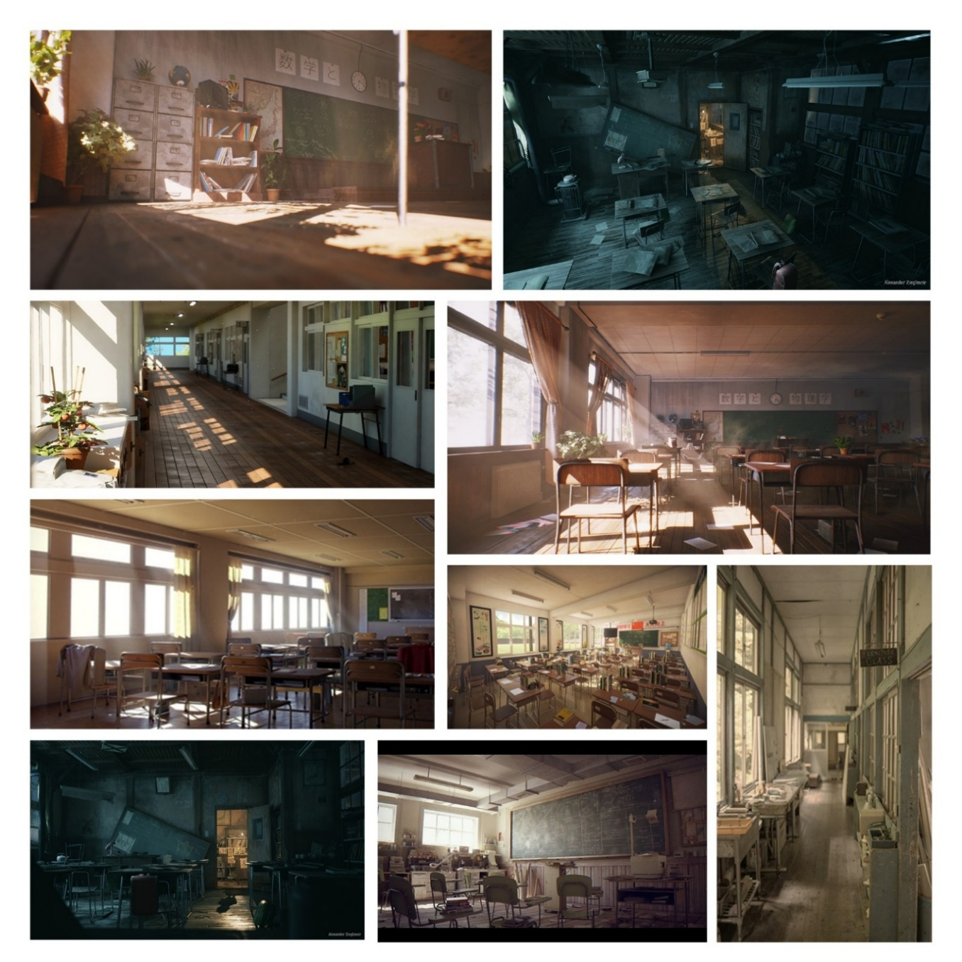

Figure 1: Mood Board

### Colour Palette

The colour scheme was meant to make people feel warm and at home, like a space that has just been vacated rather than one that has been left empty for a long time. The windows in the classroom let in gentle sunlight from the sun in the late afternoon. This contributes to the room look cosy and amber as well as beige, which makes the wood and paper look even better. The soft illumination in this location makes it feel like humans have been there to get assignments done, even though it's a complete wreck.



Figure 2: Cosy Colour Palette

The light in the next corridor was colder and less bright on purpose, which helped compose and added tonal contrast. The difference between warm and cool colours serves two purposes: it makes the two places look different and adds to the scenes vibrant journey. Together, they create a dynamic interplay of brightness and mood that affects how the player sees and feels as they move between areas.

## Level Planning & Layout

### Conceptual Arrangement

The first stage in arranging the furniture was to use Photoshop to generate a simple top-down schematic that showed how the classroom, corridor, and other objects would fit together. The goal was to make a small, readable space that worked well with mobile performance limits but still felt real in terms of size. There was going to be a longer hallway and staircase at first, but they were removed so that time could be spent on making one well-designed room.

Ein Bild, das Text, Screenshot, Diagramm, Design enthält.

Figure 3: Photoshop Level Layout

### Form & Proportions

Before diving into greater detail with the 3D modelling, I produced a blockout in Blender to verify the general size, composition, and player flow. I rapidly defined the structure using basic shapes and saw how players would see the space from above. At this point, most of the shapes were still rather simplistic. But at first, the shapes of the desks, seats, and windows were made more precise to make sure the proportions and space for interaction were correct. This useful blockout method found layout problems early on and made sure that the switch to generating assets went smoothly without having to redo any work.

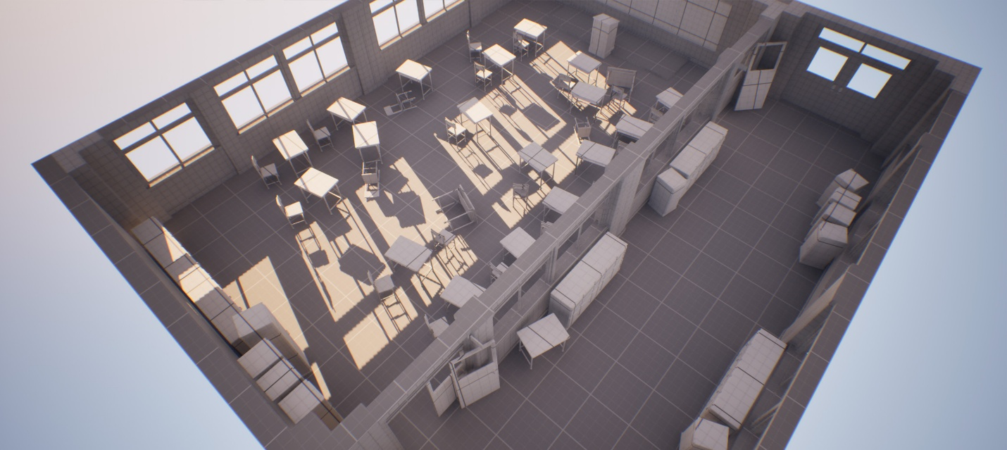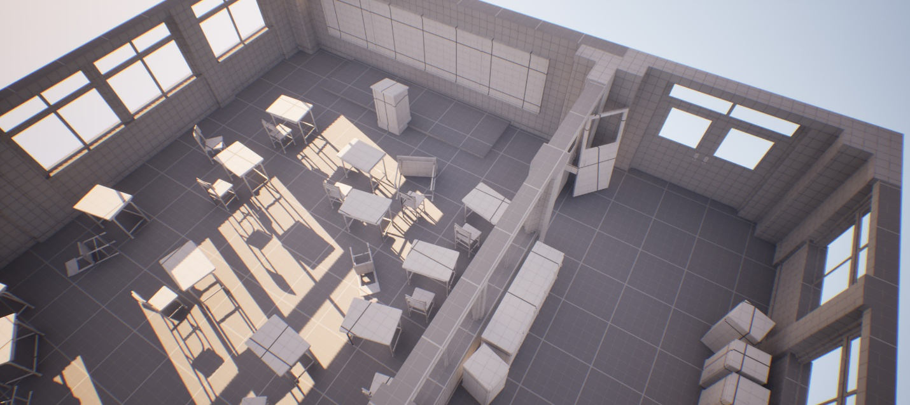

Figure 4: Unreal Engine Blockout Test

Ein Bild, das Entwurf, Behälter, Box, Schwarzweiß enthält.
Ein Bild, das Entwurf, Schwarzweiß, Behälter, Box enthält.
Ein Bild, das Gebäude, Screenshot, Haus, Fenster enthält.

Figure 5: Basic Blender Blockout

# Chapter 2 - Modelling *(Weeks 2-3)*

## Asset Overview

There were fifty assets made for Silent Lessons, and they were split into three groups to make sure they could be used in different ways and were efficient:

* **Props Modular (8):** walls, pillars, door frames, floors, and windows
* **Props Furniture (14):** doors, curtains, lockers, tables, and chairs
* **Props Detail (27):** television, papers, clock, globe, bags, umbrellas, and small props

Assets were designed to be used as frequently as possible and to keep the number of assets minimal while yet allowing for variable level composition. Multiple UV sets were implemented for key assets, particularly floors, to optimise texture usage and allow material variations without additional geometry.

## Workflow & Steps

I began by creating blockouts in Blender, using simple primitives to define the classroom and corridor layout, proportions, and player navigation from a top-down perspective. This initial stage enabled me rapidly evaluate the size, how far apart the desks and chairs were, and where the doors and windows were. When I was pleased with how the space felt, I replaced the placeholder parts with more detailed models. I made sure that the desks, chairs, and windows were the right size and had enough space to work by working on them one at a time.

I concentrated on pieces that might be used for building modular components like walls, flooring, and door frames. This manner, they could be put jointly in many different ways without having to make new meshes. They made each piece of furniture and prop on its own, but they were all designed to be able to be carted about. This makes it straightforward to make changes without increasing to the number of assets.

Modeling and UV mapping were done at the same time. Modular pieces got a lot of UV sets to support trim sheets and texture atlases. This made it easy for me to change textures without making new materials. At this point, I also checked the texel density of each asset to make sure that the top-down camera angle looked the same throughout.

During the modelling process, I repeatedly exported assets from Blender to UE to check both scale, and world alignment. Sometimes proportions felt off, so adjustments were made to ensure the environment remained at coherent scaling compared to the player.

Ein Bild, das Entwurf, Haus, Schwarzweiß enthält.

Figure 6: Blender Final Base Meshes

## Optimisation & Performance

All fifty assets together make up about 27,000 triangles. The level that was put together has about 183,000 triangles, which is well below the limit of 300,000 polygons. To cut down on the number of polygons, non-visible geometry, like the backs of walls, chairs, desks, and clocks, was taken away. Most surfaces were given smooth shading, and sharp edges were added only where they were needed to keep the shape clear. It was especially important to carefully break down curved furniture so that the silhouette stayed the same while staying within the polycount budget.

# Chapter 3 – Trim Sheets & Atlas *(Weeks 3-5)*

From the beginning, I kept the texturing process focused on performance and efficiency for mobile hardware. My main objective became to cut down the numbers of textures while keeping the materials appear and feel genuine. Each texture was limited to 1024×1024 pixels, however I tried to utilize fewer textures altogether by using trim sheets and atlases instead of building a separate map for each object.

## Planning & Design Approach

I planned out which portions of the world would need shared elements before I made any textures. This helped me decide early where a trim sheet or an atlas made sense. I built simple greyscale layout grids at 1K resolution to plan UV space and check texel density.

For some meshes, I used multiple UV sets to switch easily between different texture sections. This gave me more variation without having to make new materials. It also kept the workflow light and flexible while staying within the memory budget.

## Texture Creation

I planned out which portions of the world would need shared elements before I created any textures myself. The only external asset that was used in the project was the classroom world map, taken from “November, Blue Marble Next Generation” (Stöckli, 2004). Everything else, including paper details and signage, was created by me to keep the overall look consistent.

## Implementation

Given the goals of modularity, efficiency, and a limited texture budget, two approaches were viable for this project: **trim sheets** and **atlases**.

### **Trim Sheets**

I created two main trim sheets that covered most of the environment:

* **Architectural Trim Sheet:** used for walls, pillars, door frames, windows, and floors.
* **Furniture Trim Sheet:** used for classroom furniture such as desks, lockers, and chairs.

Both sheets were kept clean and neutral so they could be reused across different assets without looking repetitive. This approach also made later adjustments simple – I could change one texture and instantly update multiple objects.

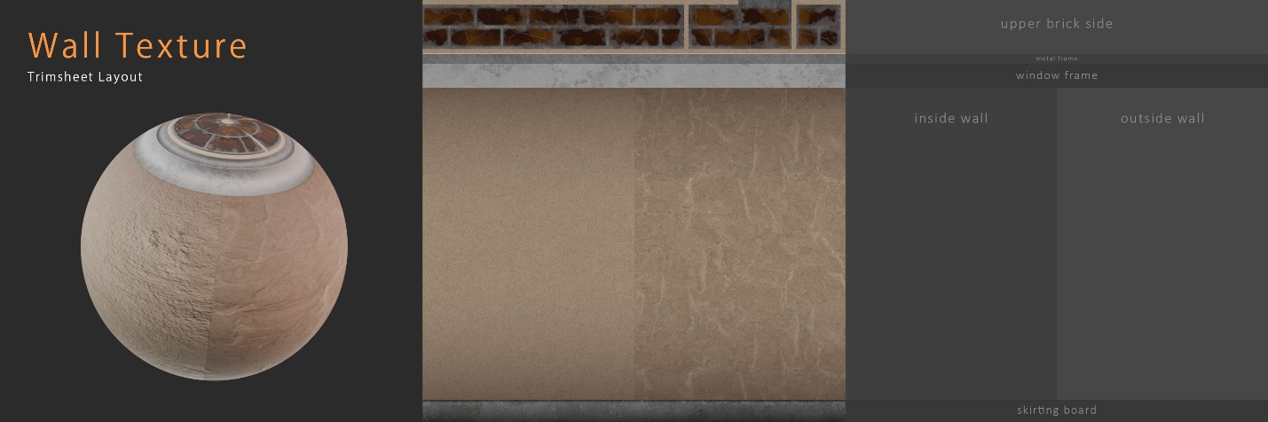

Figure 7: Trim Sheet Wall Texture

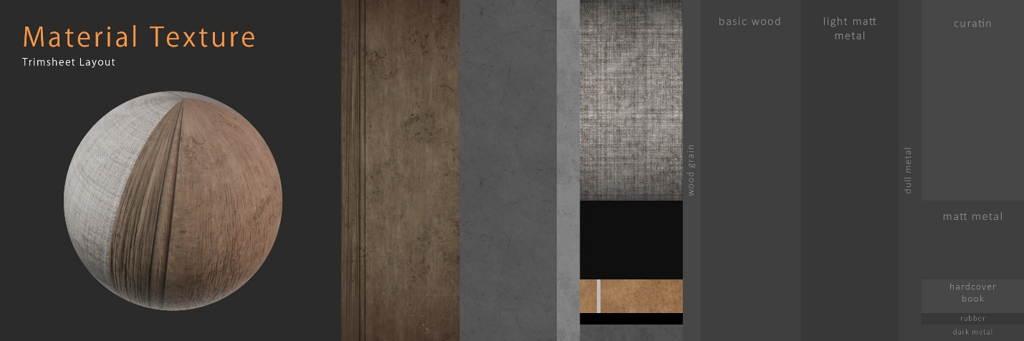

Figure 8: Trim Sheet Material Texture

### Image Atlas

Because the classroom contains a lot of printed material – notes, posters, and signage – I created a separate **image atlas** for all 2D graphics. Everything is packed into a single 1K texture.

This had two clear benefits:

* Editing or replacing any graphic was fast and didn’t affect the rest of the materials.
* Several assets could share the same texture, which reduced draw calls.

For reasons of cultural accuracy, I have replaced the entire original text with Japanese placeholder text, similar to Lorem Ipsum:

「文字の配置やバランスを確認するために使います。見た目を整えるだけのサンプル文章です。これはテスト用のテキストです。」 (Lipsum Hub, 2025)

All poster and paper designs were based on my own photographs, depicting my most recent trip to Japan, and thus fit in well with the theme and the teaching environment.

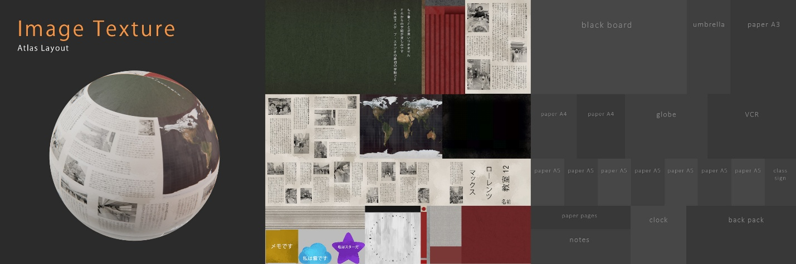

Figure 9: Atlas Image Texture

### Floor Texture

The floor uses a single texture separate from the trim sheets to allow visible variation. One floor mesh contains several UV sets, each showing a different level of wear or dirt. This gave me six quick variations without adding extra meshes or materials.

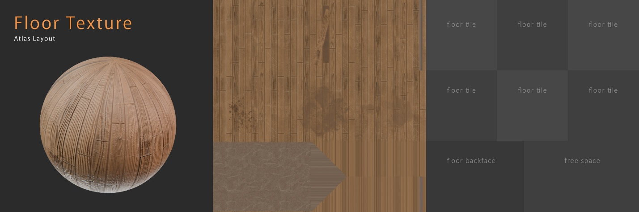

Figure 10: Atlas Floor Texture

## Material implementation

The final scene uses four materials, each with three texture maps: *Base Colour*, *Normal*, and *Metallic/Roughness/Utility (MRU)*. I tested emissive lighting early on but removed its B channel later on to reduce my file size even more. Since the project was geared towards mobile devices, **no transparency materials** were used. Most assets only use one or two material slots.

In Unreal Engine, each material can switch between UV channels, which made it easy to reuse a single texture across multiple meshes. This setup kept the project clean, fast, and easy to update. The final assets, with their applied materials, maintain visual fidelity while remaining fully optimised for mobile deployment.

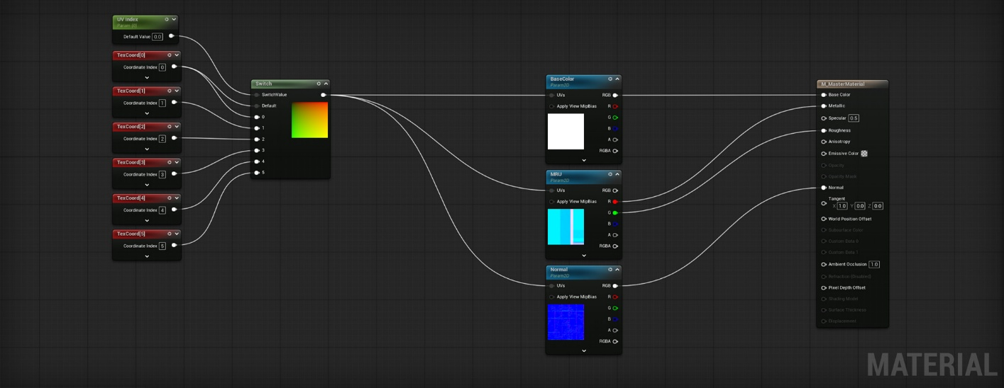

Figure 11: Master Material Unreal Graph

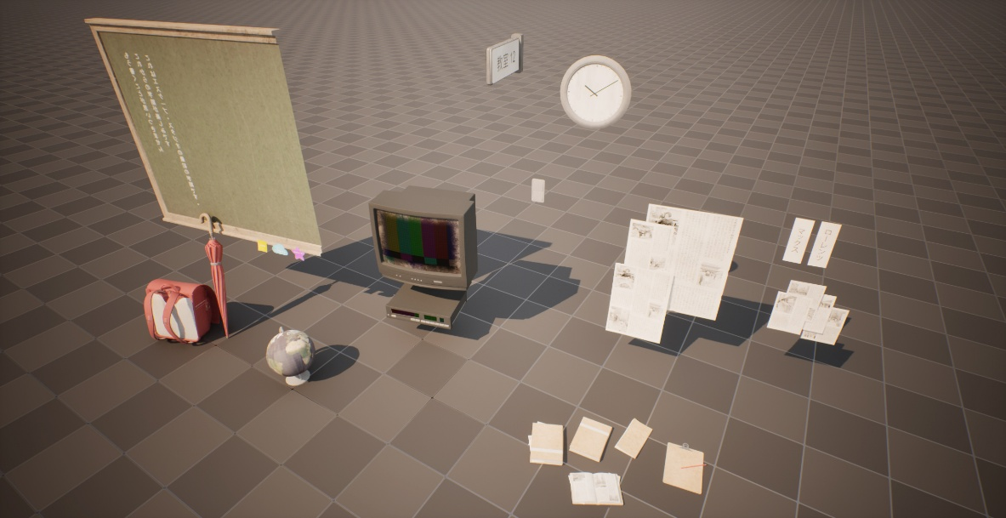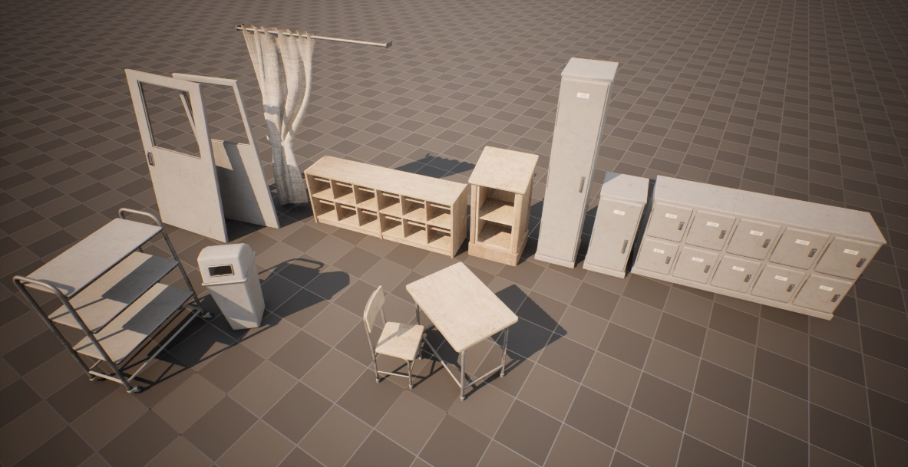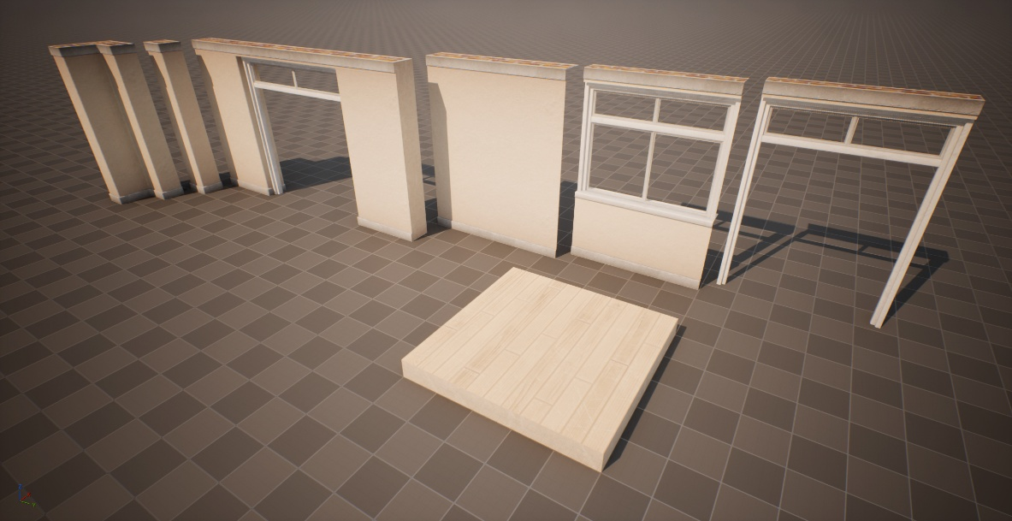

Figure 12: Unreal Assets with Material

# Chapter 4 – Lighting *(Weeks 5-6)*

Lighting became one of the most demanding stages of the project and took a large share of the available time. All lighting was baked in *Unreal Engine 5.6* using **GPU Lightmass**, which delivered solid results but occasionally produced artefacts that required manual correction. Most adjustments involved refining lightmap resolutions and smoothing indirect light distribution to keep the scene consistent from the player’s top-down perspective.

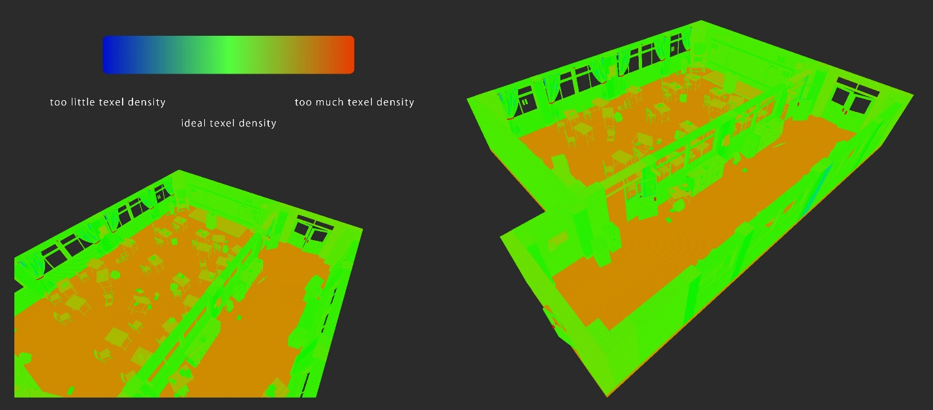

Figure 13: Level Light Density

## Challenges

Several constraints defined the lighting setup:

* The target platform was **mobile**, which ruled out post-processing effects such as colour grading, bloom, or ambient-occlusion enhancement.
* **Transparency** could not be used, making realistic window lighting or volumetric rays impossible.
* **Dynamic lights** were avoided to maintain stable performance and ensure predictable baked lighting quality.

These restrictions meant the entire lighting design had to rely solely on static lights and material contrast rather than post-effects or dynamic adjustments.

Ein Bild, das Hellbraun, Braun, Screenshot, Behälter enthält.

Figure 14: Light Colour Palette

## Approach

Lighting for the classroom and corridor was built through continuous testing and refinement. I worked mainly with a single directional light to simulate late-afternoon sunlight, and a set of low-intensity fill lights to maintain readability in darker areas.

Because of the modular layout, minor light-bleeding sometimes appeared between meshes. To reduce these artefacts, I slightly adjusted UV seams and, in some cases, introduced subtle texture noise on wall surfaces to blend transitions naturally. While these imperfections were visible up close, they were invisible from the player’s top-down view and did not affect the overall atmosphere.

The final setup preserved the warm tone and soft contrast established in the earlier colour-palette stage while remaining fully optimised for static baking.

Ein Bild, das Gebäude, Fenster, Boden, hölzern enthält.

Figure 15: Light Bake Top-Down View

Ein Bild, das Im Haus, Boden, Inneneinrichtung, Wand enthält.
Ein Bild, das Im Haus, Inneneinrichtung, Boden, Mobiliar enthält.
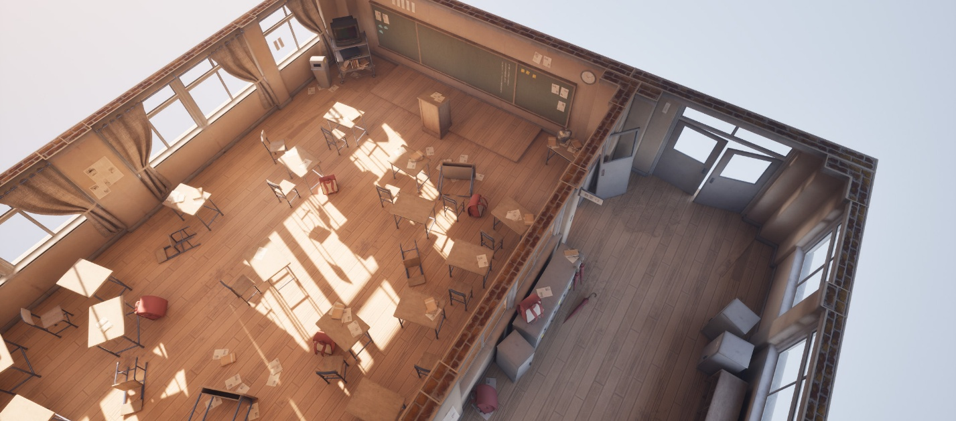

Figure 16: Light Bake Top-Down & Close-Up View

# Conclusion (retrospective)

This project let me try out both familiar and new abilities while learning how to make a top-down, mobile-friendly environment from start to finish. I had already used Unreal Engine, Blender, and modular assets before I started working on Silent Lessons. This made it easy for me to create layouts, block out the scene, and build components quickly. At the same time, light baking was a new problem that required testing GPU Lightmass, making changes to UVs, and changing materials to get the right mood while keeping the mobile limits in mind.

I encountered a variety of technical challenges. Traditional Japanese classrooms included curved furniture, which had to be carefully deconstructed to keep the polycount down yet keep the shapes recognizable. I mostly used soft shading and only used sharp edges where they proved necessary to keep the design clear without adding extra vertices. Non-visible geometry was removed across assets to further reduce polygons, and modular reuse maximised efficiency without compromising visual fidelity.

Managing textures presented additional constraints. Trim sheets and atlases were essential to limit texture count while maintaining visual variation. Planning UV space carefully and using multiple UV sets allowed me to switch textures across assets quickly. Floor variations and temporary trim sheets demanded a balance between flexibility and simplicity, as full bevelling or unique textures for every object would have exceeded technical limits.

Lighting took the most trial and error. I only used static baked lights as I lacked post-processing, transparency, or dynamic lighting. While artefacts remained at very close inspection, they were invisible from the player’s top-down perspective and did not affect the overall experience.

All in all, the endeavour showed how important it is to establish a strategy, refine, and deal with obstacles while working with stringent performance limits. I developed across methods to make modular designs, improve textures, and light them up in a way that worked with mobile devices' constraints while still looking good. The process also showed me how important it is to use abilities I've learned in the past to solve new technical problems, including light baking. It also helped me get better at making decisions that help both the plot and the gameplay.

# Bibliography

Stöckli, R. (2004) *November, Blue Marble Next Generation* [Satellite image]. Available at: <https://visibleearth.nasa.gov/images/74192/november-blue-marble-next-generation/74194l> (Accessed: 24 October 2025).

Lipsum Hub (2025) *Japanese Lorem Ipsum Generator*. Available at: [https://blog.lipsumhub.com/japanese-lorem-ipsum-generator/](https://blog.lipsumhub.com/japanese-lorem-ipsum-generator/?utm_source=chatgpt.com) (Accessed: 24 October 2025).

# List of Figures References

**Figure 1: Mood Board**

Veldhuizen, B. (2019) *JClassroom_A* [3D environment]. Available at: <https://www.blendernation.com/2019/02/08/best-of-blender-artists-2019-week-6/diaz_tim_2019_jclassroom_a> (Accessed: 24 October 2025).

HaHyun (2025) *Japanese School – Hallway* [3D environment]. Available at: <https://hahyun.artstation.com/projects/GvGWb4> (Accessed: 24 October 2025).

Mansour, M. (2023) *Japanese Classroom* [3D environment]. Available at: <https://malekm.artstation.com/projects/PXxoZZ> (Accessed: 24 October 2025).

Rodrigues, R. (2025) *Japanese Classroom* [3D model]. Available at: <https://www.fab.com/pt-br/listings/7af4f84d-2032-45b9-8394-23c646a61675> (Accessed: 24 October 2025).

Wang, A. (2017) *Japanese Classroom Interior* [3D environment]. Available at: <https://arthur_9527.artstation.com/projects/44g2k> (Accessed: 24 October 2025).

Studio Aiko (2010) *Classroom* [3D render]. Available at: <https://www.ronenbekerman.com/classroom-by-studio-aiko> (Accessed: 24 October 2025).

Zieglmeir, A. (2020) *Abandoned Japanese Classroom [UE4]* [3D environment]. Available at: <https://bigziegel.artstation.com/projects/PooBXr> (Accessed: 24 October 2025).

泼墨•韶华 (2017) *青春，带着另人难以捉摸的色彩 […]* [Facebook post]. Available at: <https://www.facebook.com/beautifulmoments2018/posts/1976580702554050> (Accessed: 24 October 2025).

I acknowledge the use of ChatGPT (GPT-5, <https://chat.openai.com/>) to proofread the spelling, grammar, and punctuation in my retrospective.